**GAME DESIGN DOCUMENT**

**JUST ANOTHER CUBE**

**Erno Viitanen 0585900**

1. ***Executive Summary, Quick overview***

“JUST ANOTHER CUBE” is an isometric puzzle game where you solve puzzles and move into another level. Game is targeted as a two-player game that can also played with only one player.

***2. Target Audience***

This game is targeted for ages 10+, and is not specific to any gender.

1. ***Main Characters***

Main controllable characters in this game are Player 1 and Player 2. When playing on your own you have to control both characters to complete some of the puzzles.

***4. Main Features***

*4.1 Main mechanics*

There are different sizes of cubes on a platform that you can move or destroy to complete the puzzle and move on to a next level. In later levels players can pick up powerups from the platform to be able to destroy cubes.

*4.2 Movement*

Player 1 moves around using arrow+ctrl keys.

Player 2 moves around using wasd+space keys.

Players turn using horizontal keys and moves forwards and backwards using vertical keys. Ctrl and Space are used as a modifier key to interact with objects in the game.

*4.3 Physics*

There are simulated physics revolving around cubes on the platform. When a player falls from a platform it merely drops back on the same platform, resetting the players position on the platform.

*4.4 Multiplayer mode*

Game is an old-school co-op game where you control characters from same computer keyboard.

***5. Genre, Setting, Concept Art book\****

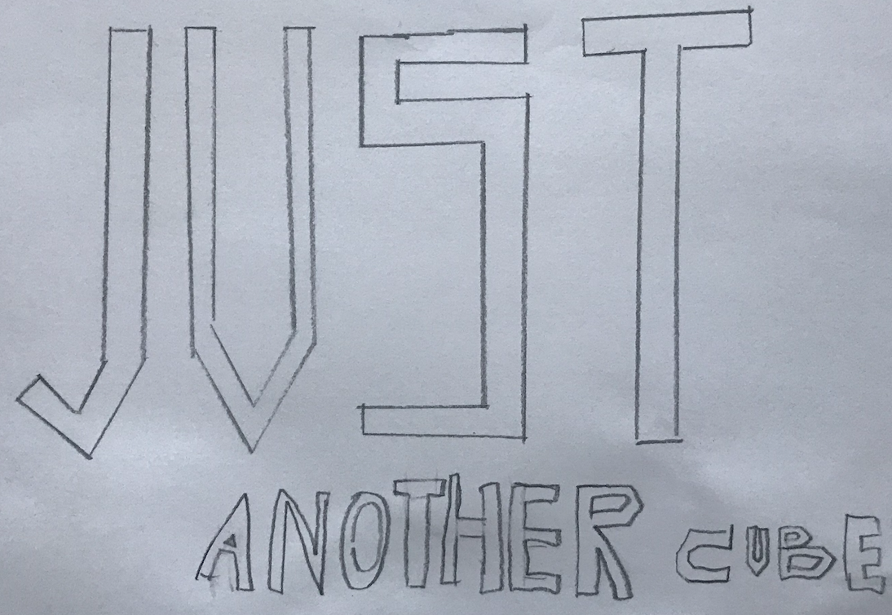 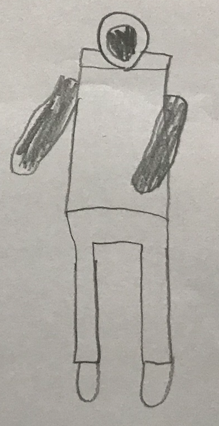

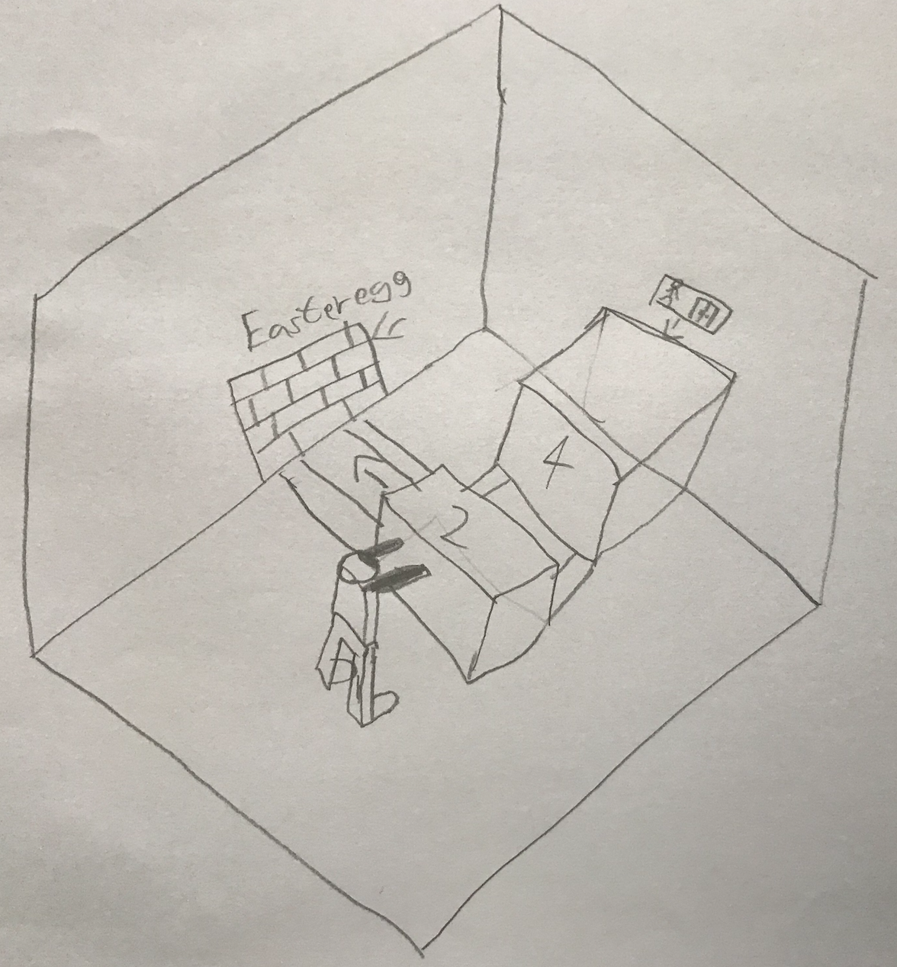 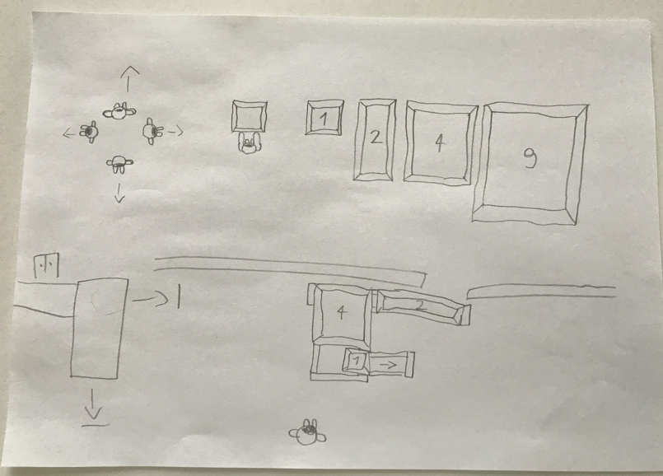

***6. Enemies, NPCs, Other objects***

Powerups can be picked up in later levels to destroy some cubes.

***7. Story board, script\****

*Players drops down from the sky and lands on a platform where you begin your first puzzle level.*

***8. Technical definitions, Tech guide\****

*Game is targeted for desktop computers. It can be played through a web browser.*

***9. Business definitions\****

*Game is a free-to-play game with ability to buy additional levels or enhancements for a small fee.*

***10. Outsourced/Bought Assets***

*Concept art is made by my son Niko Viitanen.*

*Topics with (*) usually extended to separate detailed documents, in this project can be simply summarized*